**The Match Process in Uploads**

LegCRM gives you full control over whether uploaded constituents will be considered to be new constituents or to match existing constituents in your database. You control when a record on your input file will be treated as being about a person already in the system. Is it enough that they have the same first and last name? Or do you also want to require date of birth to be identical? Or also require street address?

If records match, say on first name and last name, then the data in your input file will be used to update the record on the database. If a record on the input file matches no one on the database, then it will be added as a new constituent record. ( You can override these decisions in settings in the default setting step.)

You should try to match as many as possible using strict criteria and then use looser criteria to match out others for whom you may have incomplete or imperfect data. LegCRM attempts matches between the upload file and your existing database records in multiple passes in the order that you prioritize the match criteria. You should usually proceed from most specific to least specific, but what is most specific ( i.e., most likely to be unique ) may vary depending on your data.

Note: You can test alternative match sequences — you are not stuck with the results of the match process. You can back up and rematch. The match options shown include only those for which you have fields mapped.[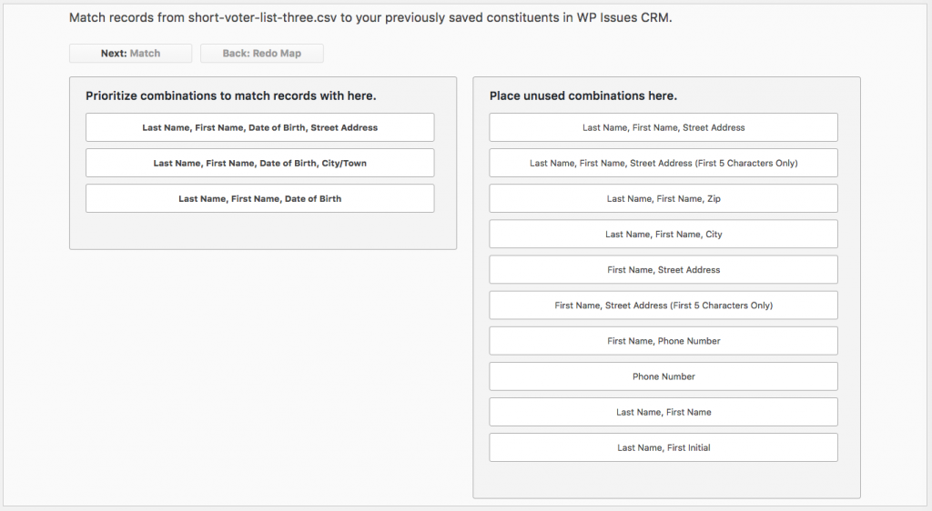](http://wp-issues-crm.com/wp-content/uploads/2016/10/uploadmatch.png)

If records are unmatched after all passes but possess the matching fields you prioritized for at least one match pass, they will be flagged as possible additions as new constituents. They will be grouped with records containing the same values for the matching fields in the first pass in which they were unmatched. Constituents will not be added unless at least one of the input records so grouped contains a core identifier — last name, first name or email — making the new constituent viable.